National Gallery of Ireland

Climate Action Roadmap

2025

Document Title | Document Number | Version Number | Contact Person Lead Responsible | Date Approved | Next Review Date
Climate Action Roadmap 2025 | National Gallery of Ireland- CLRM-001-2025 | Rev 2 | Gillian De Marco |  | 30/06/2026
Climate Action Roadmap 2024 | National Gallery of Ireland- CLRM-001-2024 | Rev 1 | Gillian De Marco | 02/12/24 | 30/06/2025
Climate Action Roadmap 2022 | National Gallery of Ireland- CLRM-001-2022 | Rev 0 (Original) | Andrew Hetherington | 29/09/23 | 30/09/24

Approval: | - Director  - ELT
Amendment History: | Sections Added / Deleted/ Amended:
29/07/2025 | All sections updated to reflect updated guidelines & progress  Substantial restructuring of Section 2 (Climate Action Targets)
28/06/2024 | Details were added to document under the following headings:  - Single Use Items  - Construction  - Water  - Paper  - Food Waste  - Building Stock Planning  - Installation of charging infrastructure
Signed:
Director
Date:

Contents
A Message from the Director 5
1 Introduction 6
1.1 About This Roadmap 6
1.2 National Context and Public Sector Mandates 6
1.3 Organisational Commitment to Climate Action 6
2 Our Climate Action Targets 7
2.1 Overview 7
2.2 Supporting Policy and Legislative Frameworks 7
2.3 Progress to Date 7
2.3.1 Greenhouse Gas (GHG) Emissions 7
2.3.2 Energy Efficiency 9
2.4 Closing the Gap 10
2.4.1 Overview 10
2.4.2 Operating Environment 10
2.4.3 Infrastructure and Heritage Building Considerations 10
2.4.4 OPW Tenancy 10
2.4.5 Capacity and Resource Limitations 11
2.5 Achieving our Targets 11
2.5.1 Planning Framework 11
2.6 Register of Opportunities 12
3 Our People 14
3.1 Leadership & Governance 14
3.1.1 Governance Structure 14
3.1.2 NGI Green Team 14
3.1.3 Climate & Sustainability Champion 15
3.1.4 Energy Performance Officer 15
3.2 Staff Engagement and Training 16
4 Our Way of Working 17
4.1 Monitoring & Reporting 17
4.2 Energy & Environmental Management System 18
4.3 Green Public Procurement (GPP) 18
4.4 Food 18
4.5 Paper 18
4.6 Water 19
4.7 Other Materials 19
5 Our Buildings & Vehicles 19
5.1 Our Buildings 19
5.2 Master Development Plan 19
5.3 Our vehicles 20
Appendix – Compliance & Legal Requirements 21

A Message from the Director

Dear colleagues and stakeholders,
I am pleased to introduce the National Gallery of Ireland's Climate Action Roadmap 2025. This Roadmap reflects on last year’s objectives, states what has been completed to date, and sets out what the Gallery strives to achieve in 2025.
Sustainability is at the center of the National Gallery of Ireland’s work, forming the foundations for our strategic plans, decision making and future building plans. In conjunction with the Climate Action Plan (CAP21) and the Public Sector Climate Action, the 2025 Roadmap outlines the Gallery’s plans to achieve a 51% reduction in our Greenhouse Gas emissions by 2030, a 50% improvement in energy efficiency by 2030 and net zero energy-related emissions by 2050 or sooner.
The National Gallery of Ireland is housed in a combination of historic and more modern buildings owned and managed by the Office of Public Works (OPW). As a tenant of historic buildings we face unique challenges in managing energy use and the ability to retrofit or install infrastructure that will reduce the Gallery’s carbon emissions. It should also be noted that a key driver of our carbon emissions is the necessity to house our collection in highly-controlled environments (narrow temperature and humidity ranges), which currently use fossil fuels to maintain these controls. Despite these challenges, we remain steadfast in our resolve to lead by example, not only as one of Ireland’s most visited free attractions, but as a cultural beacon demonstrating how sustainable practices can protect our national collection, enrich visitor experiences, and safeguard the environment.
As a public sector body, we are committed to supporting the Government's efforts to achieve its emissions reduction targets and to transition to a low- carbon economy. Our Climate Action Roadmap outlines a range of activities we will implement, measure, and assess, to reduce our emissions where feasible and where under our control. Energy efficiency is a core element of our activities, and while we recognise that further improving the National Gallery of Ireland’s energy efficiency is a challenge, it is essential.
These measures include upgrading our energy meter monitoring in collaboration with our landlord, the OPW, enhancing heating and cooling systems, implementing energy management systems, and embedding sustainable practices at every opportunity, across all aspects of our operations.
The Gallery continues to work closely with the OPW’s architects on the plans for the refurbishment of 88-90 Merrion Square, and the temporary occupation of Number 7 Merrion Square as office space, as well as on our broader Master Development Plan. The Office of Public Works and the Department of Culture, Communications and Sport are vital partners in the operation and development of the National Gallery of Ireland’s campus, and the completion of the final phase of our Master Development Plan. As a result, they are critical agents for the success of this Roadmap.
This Roadmap is a living document. It will be reviewed and updated next in 2026 and annually thereafter, ensuring that we remain accountable in all our climate action practices.

Dr Caroline Campbell
Director
National Gallery of Ireland

Introduction
The Climate Action Plan 2021 (CAP21) committed that all public sector bodies must complete a Climate Action Roadmap by the end of 2022. A Climate Action Roadmap is a document which communicates how each public sector body aims to meet the latest requirements of the Public Sector Climate Action Mandate (the Mandate) and reach its 2030 carbon and energy efficiency targets. It should be reviewed annually and updated within sixth months of the publication of the latest Climate Action Plan.
This document is the National Gallery of Ireland’s Climate Action Roadmap (the Roadmap). It focuses on our energy-related greenhouse gas emissions within our operations, in line with the target of a 51% absolute reduction by 2030. This Roadmap aligns with our vision of achieving the climate actions and targets we have set ourselves.
The Roadmap has been approved by the Director of the National Gallery of Ireland. It will be reviewed and updated annually by the executive and presented to the Director and Board for approval. The annual review will assess our progress, report our gap-to-target and will incorporate any updates or revisions to the National Climate Action Plan, the Mandate and changes to Guidance for Roadmaps. Our climate action activities are reported in our annual report from 2023 onwards.

About This Roadmap
This Roadmap outlines the Gallery’s strategy to reduce greenhouse gas (GHG) emissions and improve energy efficiency in line with national public sector targets. It builds on previous versions (2022 and 2024), reflects updated data and strategic assessments, and sets out a pathway to achieve a 51% reduction in energy-related carbon emissions and a 50% improvement in energy efficiency by 2030. It also reports on the Gallery’s progress against other actions as outlined in the Mandate.

National Context and Public Sector Mandates
The National Gallery of Ireland, as a public sector body, operates within the framework of Ireland’s Climate Action Plan and is required to meet binding emissions and efficiency targets under the Mandate. These mandates compel public bodies to lead by example, improve performance through regular audits, and embed sustainability across governance, operations, and procurement processes.

Organisational Commitment to Climate Action
The National Gallery of Ireland is fully committed to playing its part in Ireland’s national climate goals. Climate action is integrated into the organisation’s strategic priorities, with dedicated governance structures, a Climate & Sustainability Champion, and a Green Team in place. Through continuous monitoring, staff engagement, and practical interventions, the Gallery aims to operate as an environmentally responsible cultural institution while recognising the unique constraints associated with heritage infrastructure.

Our Climate Action Targets

Overview
In alignment with the mandate and the Climate Action and Low Carbon Development Act, the National Gallery of Ireland is committed to playing its part in national decarbonisation. The Gallery aims to meet and exceed the following national public sector targets:
- 51% reduction in energy related GHG emissions in 2030 (2016-2018 baseline),
- 50% increase in the improvement of energy efficiency by 2030 (2009 baseline), and
- Net zero energy-related emissions target for 2050 at the latest.
These targets are binding and reflect the Gallery’s legal and ethical responsibilities under public sector guidance, EU directives, and national law.
The targets cover all energy use associated with:
- Gallery buildings and infrastructure (where applicable under the Gallery’s control or influence)
- Transport and vehicle-related emissions
- Operational practices across administration and services
While the Gallery is a tenant of the OPW, it actively engages in planning, operations and advocacy within the boundaries of its remit to support these targets.

Supporting Policy and Legislative Frameworks
The Gallery’s targets are guided by:
- The Climate Action and Low Carbon Development Act (as amended)
- The latest Public Sector Climate Action Mandate
- Ireland’s latest Climate Action Plan
- EU directives on energy efficiency and emissions reduction.
The Gallery’s Climate Action Roadmap aligns with SEAI’s guidance for public sector climate planning and reporting.

Progress to Date

Greenhouse Gas (GHG) Emissions
GHG Emissions are calculated in accordance with SEAI’s public sector monitoring and reporting methodologies. Figure 1 shows The Gallery’s annual fossil CO₂ emissions from 2016-2024. Transport emissions for the Gallery are negligible, with almost 100% of emissions associated with the combustion of natural gas for CHP operation and space heating purposes.

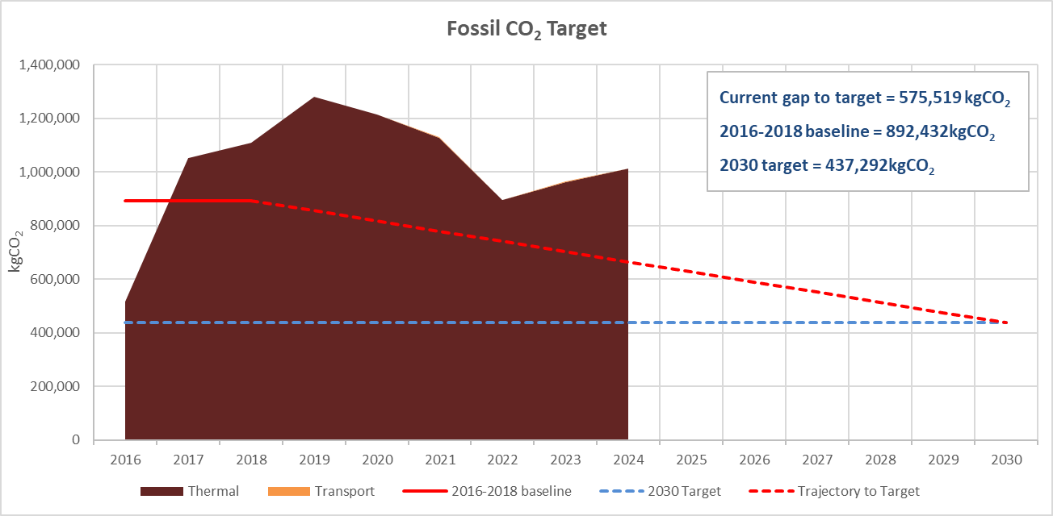
Figure 1: The Gallery’s Fossil CO₂ target – Progress to date (Source: SEAI Monitoring & Reporting System)

The 2016-2018 baseline period represents a particular challenge for the Gallery, since the Dargan and Milltown wings reopened to the public in 2017 following extensive repair and restoration. 2016 emissions were roughly half the annual emissions since the reopening, suppressing the baseline and making the achievement of the 2030 target even more challenging.
The chart shows that, following consistent reduction in annual emissions from 2019-2022, fossil CO₂ has increased over the last two years and was 13.5% higher than the baseline in 2024. The gap-to-target based on 2024 emissions is 575.5 tonnes CO₂, with a 56.8% reduction in fossil emissions required in order to meet the 2030 target.
Figure 2 shows The Gallery’s total energy-related CO₂ emissions from 2016-2024. The Gap to Target in 2024 was 1,125.2 tonnes CO₂. A reduction of 42.4% is required to meet the 2030 target relative to business as usual.

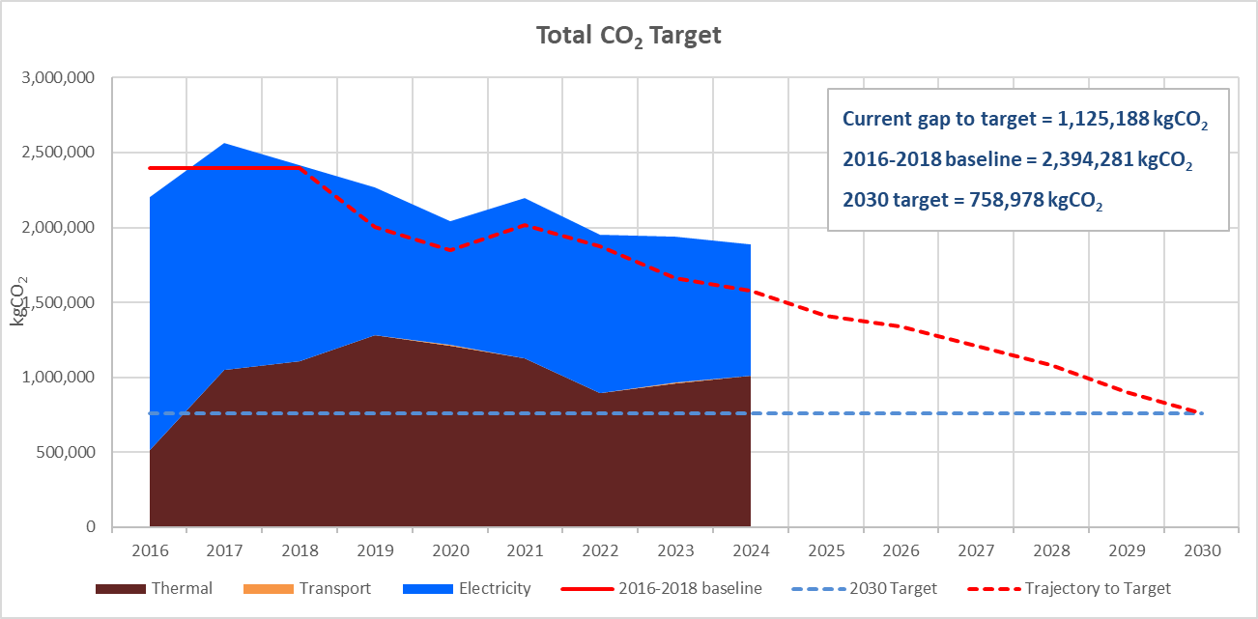
Figure 2: The Gallery’s Total CO₂ target – Progress to date (Source: SEAI Monitoring & Reporting System)

The baseline, 2030 target, projected business as usual 2030 emissions, and gap to target are summarised in Table 1.

Table 1: Summary of performance and gap to GHG emissions target
 | Fossil CO₂ (tonnes) | Total CO2 (tonnes)
Baseline (2016-2018) | 892.4 | 2394.3
2024 emissions | 1,012.8 | 1,884.2
2030 BAU | 1,012.8 | 1,318.8
2030 Target | 437.3 | 759
Gap to Target (GTT) | 575.5 | 559.8

Energy Efficiency
The Gallery is now reporting its energy performance using the normalised Energy Performance Indicator (EnPI), in line with SEAI guidance.
Figure 3 shows the Gallery’s performance to date against the target of 50% improvement in energy efficiency by 2030, relative to a 2009 baseline. While significant savings were made over the period 2010 to 2020, progress has slowed since then, with emissions increasing since 2022. Current normalised EnPI is 70.6%, and 6.3% above the linear trajectory to the 2030 target.

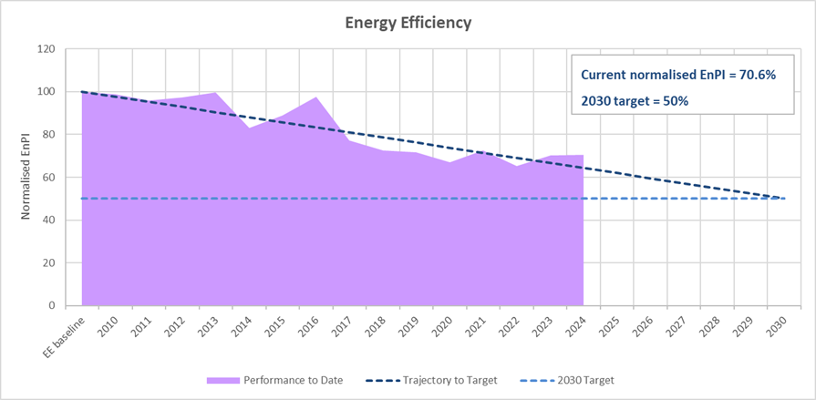
Figure 3: Energy Efficiency target – Progress to date

The baseline, 2030 target, projected business as usual EnPI, and gap to target are summarised in Table 2.

Table 2: Summary of performance and gap to energy efficiency target
Energy Efficiency Target | Normalised EnPI
Baseline (2009) | 100%
2024 EnPI | 70.6%
2030 BAU | 62.2%
GTT | 12.2%

Closing the Gap

Overview
The Gallery’s ability to meet its targets is shaped by a specific operating environment that includes heritage, institutional and resource-related constraints. Understanding these constraints is essential to inform the roadmap to closing the gap to target for greenhouse gas reduction and energy efficiency improvement, and to understand the pace of progress.

Operating Environment
Space conditioning, in terms of heating, cooling, and humidity control, accounts for the majority of the Gallery’s energy consumption. These systems are essential to ensure the preservation of artworks. This makes space conditioning the Gallery’s most significant energy user.
Unlike more flexible energy loads, these requirements are dictated by international conservation standards which necessitate temperature and humidity to be tightly controlled within narrow bands. While some optimisation is possible, reductions must be balanced against curatorial and conservation needs.

Infrastructure and Heritage Building Considerations
The Gallery operates within protected structures of significant architectural and cultural heritage value. This imposes strict conservation constraints on the types of interventions that can be made. Retrofitting for energy efficiency, such as window replacement and external insulation is limited by statutory protections and the need to maintain adequate conditions for the collection.
As a result, energy saving projects tend to be more expensive due to the highly bespoke nature of the projects, and are often subject to longer timelines due to planning and conservation requirements. These factors can limit the scale and pace of carbon reduction achievable in the short term.

OPW Tenancy
The Climate Action Plan 2025 introduced the concept of National Estate Portfolio Leads (NEPL) for particular subsectors. NEPLs have been tasked with planning and coordinating/delivering deep retrofits of the building stock in their sector. Public bodies within these sectors need to liaise with NEPL on planning deeper measures, whilst continuing with energy management, control optimisation and other measures within their control.
The Gallery is a tenant of the OPW, which owns and manages the buildings it occupies. The OPW has been identified as the NEPL for the buildings within their portfolio. As such, strategic decisions around retrofits, heating infrastructure upgrades, and procurement for construction are typically made by the OPW (as the NEPL for the sector), and are subject to their timelines and budgets.

Capacity and Resource Limitations
In 2023, the Gallery established its first Green Team to lead and coordinate sustainability efforts across the organisation. This marked a significant step in embedding environmental responsibility into the Gallery’s operational culture.
Building on this momentum the Gallery appointed Byrne Ó Cléirigh Consultants as its dedicated sustainability consultant in 2025. This strategic partnership will support the development of a comprehensive sustainability framework tailored to The Gallery’s unique context and constraints.
The Gallery operates within finite financial and human resources. Nevertheless, meaningful progress has been achieved through the formation of the Green Team and the engagement of expert consultancy. These initiatives reflect the Gallery’s commitment to integrating sustainable practices into its long-term planning and daily operations.

Achieving our Targets

Planning Framework
To meet our 2030 climate targets and align with the Public Sector Mandate (the Mandate), the Gallery has developed a phased, multi-year implementation approach. This framework reflects our unique operating context as a tenant of the OPW, the heritage nature of our buildings, and the collaborative role of our key stakeholders.

 | Plan | Status
Phase 1:  Planning & Strategy Development | Initial energy audit of all Gallery buildings conducted in partnership with the OPW | Complete
Phase 1:  Planning & Strategy Development | Sustainability consultancy engagement | Complete
Phase 1:  Planning & Strategy Development | Developed a comprehensive decarbonisation strategy | Strategy being prepared for Presentation to Green Team in Dec. 2025
Phase 1:  Planning & Strategy Development | Develop Register of Opportunities | Register being prepared for Presentation to Green Team in Dec. 2025
Phase 1:  Planning & Strategy Development | Define emissions reduction targets for each building. | Targets being prepared for Presentation to Green Team in Dec. 2025
Phase 1:  Planning & Strategy Development | Identify infrastructure and operational adjustments to support emissions reduction. | Proposed adjustments being prepared for Presentation to Green Team in Dec. 2025
Phase 1:  Planning & Strategy Development | Develop a capital budget plan to support implementation, for use in discussions with the OPW and the Department of Culture, Communications and Sport | Jun-2026
Phase 2  Monitoring and Reporting | Ongoing monitoring of energy usage and GHG emissions to evaluate performance against targets. | We are continuing to monitor energy usage and GHG emissions both internally and externally with OPW Energy Optimal Team.
Phase 2  Monitoring and Reporting | Annual reporting to key stakeholders, including summaries in the Gallery’s annual report, to maintain transparency and momentum. | Green Team provide continued updated summaries for inclusion in annual reporting.
Phase 2  Monitoring and Reporting | Evaluate and adjust the energy management plan as necessary based on monitoring and reporting results. | Ongoing
Phase 3  Education and Training | Deliver ongoing staff training and awareness programmes, including workshops, campaigns, and events. | Ongoing
Phase 3  Education and Training | Promote behavioural change through targeted engagement with Gallery staff and building occupants. | Ongoing
Phase 3  Education and Training | Encourage participation in energy conservation initiatives, reinforcing a culture of sustainability. | Ongoing
Phase 4  Energy Efficiency Improvements | Identify and implement Reduce Your Use initiatives throughout Gallery operations. | Ongoing
Phase 4  Energy Efficiency Improvements | Gallery Plant Metering Installation:  Energy Meter monitoring will be provided in the following locations:  - Main Energy Centre - Dargan & Milltown Wing  - Clare Lane Main SW. Room  - Old Energy Centre Switch Room (but subject to a more extensive survey of the switchgear)  - Main incoming Gas supplies and CHP | Works have been scheduled to commence with the installation of metering in Q2 2026
Phase 4  Energy Efficiency Improvements | Assess and incorporate building modifications aligned with the Gallery’s Master Development Plan (MDP). | Jun-2026
Phase 4  Energy Efficiency Improvements | Review and revise the MDP to strengthen alignment with climate and energy objectives. | Dec-2026
Phase 4  Energy Efficiency Improvements | Explore and assess other innovative approaches to improving energy performance (based on Register of Opportunities) | 2025-2029
Phase 5: Renewable Energy Transition | Conduct feasibility studies on renewable and low-carbon energy options, including:  - Heat pumps  - Solar PV  - Biofuels and biomass | 2025-2029
Phase 5: Renewable Energy Transition | Where feasible, and in collaboration with the OPW, initiate a transition to renewable power sources in line with decarbonisation objectives. | 2025-2029

Register of Opportunities
In conjunction with our Sustainability Consultant, the Gallery is developing a Register of Opportunities to list potential initiatives aimed at improving energy efficiency and sustainability. While still under development, the following priorities have been identified for further investigation in 2025-26.
- Review of onsite metering in conjunction with OPW, with a view to identifying additional submetering which will improve understanding of energy consumption across the building. At present, only building level utility supply meter data is available. Additional submeter information on both electricity and gas consumption will contribute to a more thorough understanding of energy consumption by Significant Energy Users (SEUs) within the Gallery estate, and is key to identifying wastage and optimising performance.
- Investigate the costs, benefits and infrastructure implications of switching off the CHP unit, with the aim of ceasing CHP operation before 2030. While operation continues to deliver total primary energy savings, overall CO₂ savings associated with CHP unit are reducing as the electricity grid is decarbonised, while operation of the unit increases the fossil CO₂ emissions attributable to the Gallery and makes it more challenging to meet the 2030 reduction target.
- Investigate the high night-time electrical load and identify HVAC control options to reduce night time load, including the feasibility of reducing fresh air intake and reducing AHU throughput when the building is unoccupied.
- Complete a feasibility study for a pilot investigation of the space heating control parameters in a representative area of the main gallery space. The aim of the pilot study would be to assess the potential energy savings and implications for conditioned space associated with widening the control parameters, in order to inform discussions regarding national and international temperature and humidity standards.

Our People

Leadership & Governance

Governance Structure
The Gallery’s governance structure for climate and sustainability is shown in Figure 4.
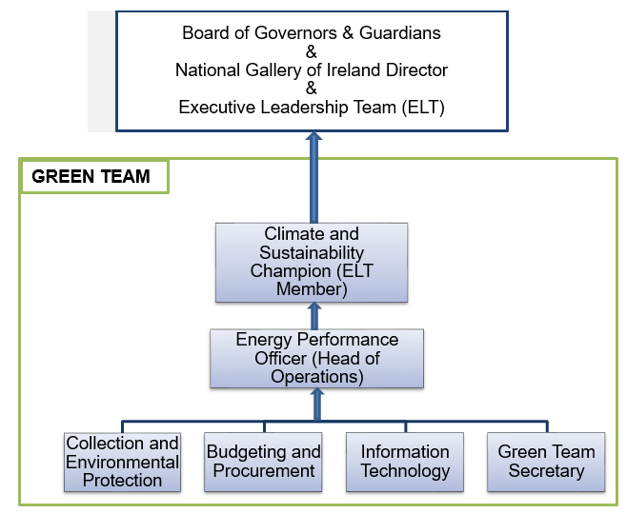
Figure 4: Governance Structure for Climate & Sustainability

The National Gallery of Ireland Green Team
The Gallery has established a Gallery Green Team, which reports to the Executive Leadership Team (ELT). The Green Team serves as the integrated driver of sustainability within the Gallery. The Terms of Reference for the Green Team committee have been approved by the Director and the Board of Governors and Guardians; they have also appointed an executive to commence the work of the Green Team.
The Green Team’s responsibilities include:
- Preparing and reviewing the Gallery’s Roadmap on an annual basis.
- Presenting the Gallery’s Roadmap to the Director and the Board of Governors and Guardians for approval.
- Developing a Sustainability Policy and presenting it to the Director and the Board of Governors and Guardians for approval.
- Setting out the Green Team’s technical work streams including annual workshops/events.
- Focusing on energy decarbonisation and outlining the steps required to meet or exceed our 2030 targets.
- Identify gap-to-target strategic projects for the reduction of carbon footprint.
- Implementing the Gallery’s Reduce Your Use (RYU) Policy.
- Establishing a working group of local Sustainability Champions to drive awareness and engagement with all staff.

The Green Team members are:
Name | Role & Responsibility | Email Address
Gillian De Marco –  Director of Corporate Services | Climate and Sustainability Champion (C&SC).  ELT member and reports directly to the Director. | GDeMarco@ngi.ie
Christiaan Clotworthy – Head of Operations | Energy Performance Officer (EPO).  Oversees the strategic implementation of the Climate Action Plan with regard to future capital works. | cclotworthy@ngi.ie
Andrew Hetherington – Head of Audience Development & Stakeholder Engagement | ELT member and reports directly to the Director. | ahetherington@ngi.ie
Ciaran Troy – Facilities Manager | Manages Facilities and Energy by identifying operational savings, upgrading existing plants and services, and supporting the Climate Action Plan. | ctroy@ngi.ie
Bernadette Kenny – Finance Business Partner | Budgeting & procurement for the Climate Action Plan. | bkenny@ngi.ie
Muirne Lydon - Conservator | Environmental protection of the Collection. | mlydon@ngi.ie
Anne Hodge –Curator | Sustainable practices in temporary exhibitions. | ahodge@ngi.ie
Jane Brennan – Head of Legal & Risk | Compliance and reporting. | jbrennan@ngi.ie
Silvia Poppmeier – Reduce Your Use Coordinator | Coordinator of all Green Team initiatives & activities. | spoppmeier@ngi.ie
Please refer to the Gallery’s Green Team Terms of Reference for further details on the Green Team.

Climate & Sustainability Champion
In 2024 the ELT appointed Gillian De Marco, Director of Corporate Services, to the position of Climate and Sustainability Champion (C&SC). The C&SC has responsibility for implementing and reporting on the Mandate and must be a member of The Gallery’s ELT.
The Director reports to The Board of Governors and Guardians of the National Gallery of Ireland.

Energy Performance Officer
The ELT nominated Christiaan Clotworthy, Head of Operations to act as the Energy Performance Officer (EPO). The EPO has decision-making powers with regard to facilities management, corporate budgets and procurement, along with responsibility for corporate and financial reporting. They will:
- Lead the development of our Energy Management Plan as an integral part of our Business Planning and Performance Management processes.
- Drive the implementation of the actions and projects agreed under our Energy Management Plan.
- Assign clear responsibility for implementation of our Energy Management Plan and ensure staff have the necessary training and support to carry out these tasks.
- Ensure the setting of our annual energy saving targets.
- Ensure the timeliness and quality of our annual data reports to the SEAI Public Sector Energy.
- Delegate tasks as part of annual goal setting under SEAI’s Performance Monitoring & Reporting System.
- Ensure Gallery data is input to SEAI’s Performance Monitoring & Reporting System.
- Ensure timely provision of our report for the Annual Memorandum to Government on the implementation of this Strategy.

Staff Engagement and Training
The Green Team researches, identifies, and delivers appropriate training to enhance Climate Action knowledge among the ELT and key staff. The Green Team also advises the Gallery’s HR department on incorporating relevant Climate Action training into ongoing staff learning and development. Additionally, all staff will be informed about freely available information, training, and other supports. A training needs analysis on climate action has been undertaken for all staff, and the following training needs identified. The Green Team continues to track training needs and competencies on an ongoing basis.

Target Group | Training/Workshop/Event | Status/Comment
Board of Governors & Guardians | SEAI Carbon & Energy Basics
Senior Leadership | Climate Action Leadership Training | 50% complete
Senior Leadership | Approaches to Improving Energy Performance of Heritage Buildings
Green Team | Energy Management – Creating an Energy Action Plan
Green Team | Climate Action Leadership Training | Complete
Green Team | Approaches to Improving Energy Performance of Heritage Buildings
Green Team | Decarbonising Existing Buildings  SME Business Briefing
All Staff | Staff Climate Awareness Days | Complete
All Staff | SEAI Carbon & Energy Basics | Rolled out to Working Group
All Staff | Leading sustainable change for decarbonisation | Rolled out to Working Group
All Staff | Conservation: Approaches to sustainability | All staff invited
All Staff | Saving the world from your desk | Rolled out to Working Group
All Staff | AIB Sustainability Conference | Rolled out to Working Group
All Staff | Reduce Your Use in the Public Sector – Energy Awareness Programme | Rolled out to Working Group

Where required, the Gallery’s Green Team will present information on any training needs analyses conducted to relevant stakeholders. It will also assess and present feedback on staff engagement activities and training initiatives undertaken. The Gallery will support the Green Team and staff by providing time and funding for suitable engagement activities and training opportunities.
In Q4 2023, an assessment of uptake of the ‘TaxSaver’ and ‘Bike to Work’ schemes was undertaken. The Gallery remains committed to identifying ways to enhance participation in these schemes.
In 2024, the Green Team presented to all staff at a Town Hall meeting. This presentation included a call for volunteers to join a Green Working Group and become local Sustainability Champions, whose objective is to embed sustainable practices into daily operational activities.
In 2025-26, the Green Team will host a minimum of two staff Climate Awareness Days in conjunction with the OPW to introduce the local Sustainability Champions, drive staff engagement, and share opportunities for staff to become more energy efficient. These awareness days will culminate in the rollout of a Gallery-wide campaign promoting the top five key initiatives developed by the working group.

Our Way of Working

Monitoring & Reporting
The Gallery is committed to transparent and effective monitoring and reporting of its sustainability initiatives. In line with the SEAI's M&R system, the Gallery annually reports its energy consumption, greenhouse gas emissions, and related data, fulfilling legal obligations under Regulation 5(3) of SI 426/2014. This system enables tracking progress towards the national targets of a 51% reduction in energy-related GHG emissions and a 50% improvement in energy efficiency by 2030.
Continuous improvement will be driven through regular assessments, staff engagement, and alignment with SEAI's guidelines and the Public Sector Monitoring & Reporting Programme.
The Gallery’s annual report has included a Climate Action & Sustainability Report from 2023 onwards.

Energy & Environmental Management System
The Gallery does not meet the threshold for annual energy spend that mandates ISO50001 certification. In conjunction with our Sustainability Consultant, we are currently developing an energy management programme in line with SEAI’s guidance (S.I. 426 of 2014).

Green Public Procurement (GPP)
The Gallery takes green and social considerations into account at a category level when planning its public procurement activities. Each procurement process is analysed for opportunities to include green and/or social considerations. On a case-by-case basis, these considerations are applied at an appropriate level in the tender in question. For categories with an environmental and/or social impact, appropriate weightings and technical considerations are applied in tender procedures. This includes, but is not limited to, categories like food services, cleaning, power and heat, maintenance and ICT equipment and consumables.
In 2025, the Gallery will review procurement procedures against the targets in the Green Public Procurement Strategy and Action Plan 2024-2027 and update as necessary to ensure that all requirements are adequately captured.

Food
The Gallery does not operate a staff canteen. The Gallery has contractual arrangements in place with appointed Catering Providers to provide food and beverage services to both the general public via the visitor café and for Gallery events.
The Public Sector Mandate requires that food waste generated on the premises be measured and monitored using a standardised approach to food waste measurement. All new contract arrangements related to canteen or food services are required to include measures that are targeted at addressing food waste, with a specific focus on food waste prevention and food waste segregation.
The Catering Providers manage food waste segregation, with a specific focus on food waste prevention.

Paper
The Gallery has implemented the following measures to minimise the consumption of paper and to reduce environmental impact:
- Digitisation of all invoice approval processes
- Digitisation of all papers for formal Board and Committee meetings
- Digital downloadable Gallery map available on the website
- Replacement of bleached printed paper with recycled paper.
- Finance working with C&AG to remove the need for paper sign-offs for audit purposes
- Following implementation of IT project in Q4 2025, meeting rooms in No 7 will have screens with laptop connectivity to eliminate need for paper at meetings

In 2025, the Gallery will set a baseline for paper consumption in order to facilitate measurement and monitoring of paper consumption and the setting of an appropriate annual paper reduction target.

Water
The Gallery tracks water consumption via water bills. In 2025, we will undertake further analysis of consumption with a view to setting a suitable water reduction target.
The Gallery provides back of house water cooler refill points, for staff only.

Other Materials
The Gallery has two sources of waste generation:
- Waste generated through the catering outlet
- Waste generated by the Gallery
Both sources are segregated into four streams:
- Residual/general waste
- Recycling waste
- Organic/bio-waste
- Glass recycling.
In 2025, we will undertake further analysis of waste production streams with a view to setting suitable waste reduction targets.
The Gallery ceased using disposable cups, plates and cutlery in 2023.

Our Buildings & Vehicles

Our Buildings
The Gallery has completed and uploaded details of our Stage One Building Stock Plan on the M&R Database. As noted in Section 2.4.4, the OPW, as the NEPL, is responsible for Stage 2 building stock planning.
The Gallery displays an up-to-date Display Energy Certificate in the reception area of the Millennium Wing.

Master Development Plan
In 2024, the Gallery initiated a comprehensive review of its MDP originally proposed in 2008. Led by Heneghan Peng Architects in collaboration with the OPW, the review was designed to ensure the MDP remains responsive to the Gallery’s evolving needs and is fit for purpose in the future.
This process involved a detailed reassessment of institutional requirements, taking into account significant changes in practice and operational priorities over the past decade. A series of targeted workshops were conducted throughout the year with key functional areas to capture their current and anticipated needs. These included:
- Library and archive
- Conservation laboratory
- Education center
- Exhibition and display spaces
- Back-of-house operations and staff facilities
- Commercial footprint
- Access
- Sustainability initiatives
The review also explored the potential for cost efficiencies through integration with the Georgian administration buildings on Merrion Square West. Completion of this strategic review is anticipated in 2026.
Looking ahead, the Gallery will prepare a preliminary business case to support Phase 4 of the MDP, scheduled for implementation in 2026–2027. This business case will be submitted to the Department of Culture, Communications and Sport and will outline the scope, objectives, and projected impact of the next phase of development, ensuring alignment with national cultural priorities and long-term institutional goals.

Our vehicles
The Gallery currently provides a limited number of car parking spaces dedicated to critical (security) gallery staff. The current MDP will require the elimination of all staff car parking facilities. No visitor parking is provided.
The Gallery will continue to create bicycle-friendly facilities for employees and visitors. Covered bicycle stands are currently available for visitors and staff at the Merrion Square entrance. In 2025 we continue to focus on the use of bicycles and shared mobility services among our employees and visitors. We provide details of various public transport options for visitors via our website to promote and assist our visitors in their sustainable travel arrangements.
The Gallery is currently working towards achieving the Smarter Travel Mark and is in consultation through the process of 'Expressing of Interest' with Transport for Ireland (TFI).
The Gallery will only purchase or lease zero‐emissions vehicles where available and required. It is noted that the Gallery currently has one van but no further purchases are planned in 2025.

Appendix – Compliance & Legal Requirements
The Gallery needs to be aware of our legal requirements relating to energy and climate action and acknowledge these in our roadmap.
These requirements include:
- Climate Action and Low Carbon Development (Amendment) Act 2021, which requires all public bodies to perform their functions in a manner consistent with Ireland’s climate ambition.
- SI393/2021 Energy Performance of buildings, which requires installation of Building Automation and Control by 2025, for buildings with HVAC rated output over 290kW; requires installation of electric vehicle charging points in carparks for new or refurbished buildings with more than 10 car parking spaces.
- SI381/2021 Clean Vehicles Directive, which sets targets for the procurement of clean light and heavy-duty vehicles, with the first target falling in 2025 and the second in 2030. The definition of clean vehicle changes to zero emission vehicles in 2025.
- SI4/2017 Energy Performance of Buildings, which requires all new public sector buildings built since 2018 to be “nearly zero emissions”.
- SI646/2016, which requires that public bodies procure only energy using products and vehicles that are on the Triple E register.
- SI426/2014, which requires the public sector to demonstrate exemplary energy management and requires public bodies to undertake energy audits every four years.

The total target for each individual public body is derived as follows: - 51% reduction of direct fossil fuel related CO2e emissions (thermal and transport consumption); plus - projected supply side reductions in indirect fossil fuel related CO2e emissions from electricity. Public bodies must ensure that they meet BOTH the 51% reduction in direct fossil fuel related emissions (thermal and transport) target and the overall total emissions reduction target.
The availability of the CHP unit has a key impact on annual fossil CO₂ emissions, with higher CHP operation associated with increased natural gas consumption but lower imported electricity.

