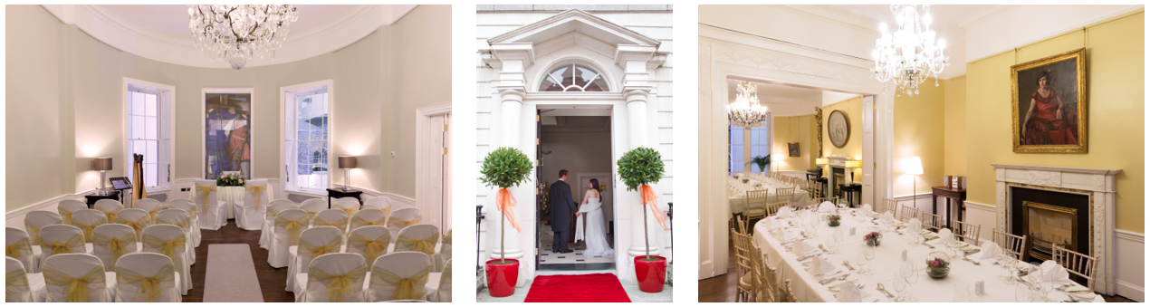
Figure 1: Different layouts for Civil Ceremonies at the National Gallery of Ireland.

The perfect location…
A suite of three inter-connecting rooms; the Lavery Room, the Clarke Room and the Purser Room. Private entrance from the street with red carpet on arrival. A choice of elegant chairs and a dedicated Events Manager on site during your wedding.
Private tours can also be arranged for guests as part of your day.
(Additional cost, talk to us for details)

Capacity

The maximum capacity for a civil ceremony or reception is 40 guests (plus the couple).

Registrar

All ceremonies must be arranged by the couple through the Registrar’s office, 3 months in advance. Couples have the option of using a state registrar or an approved celebrant.
Applications must be made in writing to:
Civil Registration Service, Eastern Registration Area,
Joyce House, 8-11 Lombard Street East, Dublin 2.
Tel: 01-8638200

Figure 2: Different layouts for Civil Ceremonies at the National Gallery of Ireland.

Catering

Couples have the option to arrange refreshments after their ceremony. Talk to us to find out more about the range of options.

Public Liability Insurance
Public Liability Insurance must be put in place for the event, and is the responsibility of those hiring the venue. Cover to the value of €6,500,000 is required. Contact your broker or Event Insure: eventinsure.ie

Payment
25% of the venue fee is required for confirmation of the booking.
The remainder of the venue fee must be paid 1 week in advance of the event.
Venue fee is subject to 23% VAT.

Figure 3: Different layouts for Civil Ceremonies at the National Gallery of Ireland.

Civil Ceremony Only
Rental of the rooms for 2 hours, between 10am and 5pm.
Lavery Room or Purser Room for the ceremony, with the option to have light refreshments afterwards.
€1,200 + VAT (Catering not included)

Civil Ceremony + Drinks Reception
Rental of the rooms for 4 hours, between 10am and 7pm.
Lavery Room or Purser Room for ceremony.
Drinks reception in adjoining rooms
€1,500 + VAT (Catering not included)

Civil Ceremony + Dinner
3.30pm – 10.30pm
Lavery Room, Purser Room and Clarke Room
€2,500 + VAT weekdays, €3,500 + VAT weekends.
(Catering not included)

