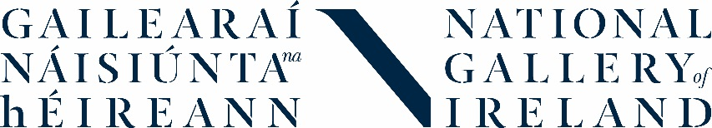

National Gallery of Ireland Teacher Network
Application Form
If you are interested in joining the Network, please fill in the short form below and return it to Catherine O’Donnell, Education Officer: Teachers, Schools & Youth: codonnell@ngi.ie
Deadline for applications: Friday 12 July 2019
Name

School

School address

Phone number
Email address
Tell us a bit about yourself (max. 100 words)

Tell us a bit about your school (max. 100 words)
(NB: We want the Network to represent a good mix of rural & urban, & primary, post-primary and special schools, so please include this information)

Why are you interested in becoming part of the National Gallery of Ireland Teacher Network? (max. 200 words)

What will you bring to the Network? (max. 200 words)

Anything else you’d like us to know?

By submitting your application, you confirm that you understand that any personal data that you have supplied to us as part of this application will be processed by us in accordance with our Privacy Notice.
It is necessary for us to process this information in order to administer your application and, if successful:
- Send you information and updates about the Teacher Network
- Connect you with other members of the Teacher Network
- Send you other relevant information and updates about the National Gallery of Ireland
Any personal data will be stored securely by the Gallery for 1 year after your application and then will be deleted, unless you continue to be a member of the Network or we are legally obliged to hold onto it for longer. Membership of the Network will be reviewed on an annual basis.

