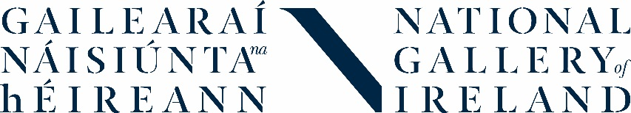
Transition Year Work Experience
8-12 April 2019
Information Pack
We run an exciting work experience programme for Transition Year students. In this week-long programme you will go behind the scenes at the Gallery and learn about the work of different departments including Education, Conservation, Curatorial and Visitor Experience. Working as a team you will develop a ‘live project’ to create an event for young people that will run at the Gallery.
The placement will suit students who are interested in art and may be considering studying it for Leaving Cert. You must be willing to work with students from other schools and be comfortable in a team environment. Most importantly, we’re looking for students who want to learn something from their week at the Gallery and benefit from a new experience.
What to expect
- You will be based in the Education Department and will find out all about the work we do
- You will also go on tours to find out about the work of different departments including Education, Conservation, Curatorial and Visitor Experience (subject to staff availability)
- Throughout the week you will work together on an exciting Live Project, developing an event for young people as part of the programme for National Drawing Day 2019. The event will take place on Saturday 18 May. We would like you to be available on this date to deliver the event
- You will receive training and support to help you develop and deliver your event
- You will develop a reflective portfolio to record your activities and experiences during your placement
- You will meet new people, develop confidence and skills, and have fun

Important information
- The placement will run from Monday 8 – Friday 12 April 2019
- Placement hours are 10.00am-3.30pm
- You must be available for the full five days of the placement
- The placement takes place onsite at the National Gallery of Ireland, Merrion Square West, Dublin 2
- You should also be available on Saturday 18 May 2019 to deliver your event
TY placements at the Gallery are very popular and places are extremely limited. In 2018-19 we will take two cohorts of students in December 2018 and April 2019. This information pack is for the April placement ONLY. We are unable to facilitate placements outside of these dates.
How to apply
- Please complete the short application form and return by e-mail to Catherine O’Donnell, Education Officer: Teachers, Schools & Youth at codonnell@ngi.ie
- You must complete the application form yourself, in your own words
- To help us process your application, we prefer forms to be typed and submitted as a Word document
- Electronic signatures are accepted
- The deadline is 5.00pm on Friday 1 February 2018. We will let you know if you have been successful by Friday 8 February.
- If you have any questions, please contact Catherine O’Donnell on 01 663 3579 / codonnell@ngi.ie

