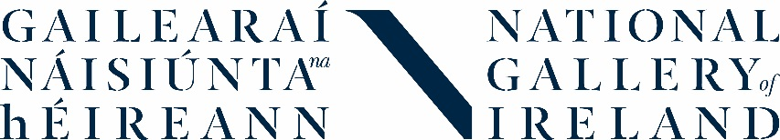
Transition Year Work Experience
Application Form
Name:
Date of Birth:
Address:
Phone Number:
E-mail Address:
School:
School Address:
School Contact/TY Co-ordinator:
Why would you like to complete your TY Work Experience at the National Gallery of Ireland?

What do you hope to learn from a placement at the National Gallery?

What are your hobbies or interests?
Are you comfortable working as part of a team?
Do you have any special requirements that you feel we should know about?
Is there any other relevant information or comments you wish to add to your application?
Please tick to confirm: | I am available Monday 8 – Friday 12 April 2019, 10.00am-3.30pm
 | I am available Saturday 18 May
 | I understand how my data will be processed (as outlined below)
 | I completed this application myself
Signed (applicant) |  | Date
Signed (parent/guardian, if applicant is aged 16 or under) |  | Date

By submitting your application, you confirm that you (or your parent/guardian if you are aged 16 or under) understand that any personal data that you have supplied to us as part of this application will be processed by us in accordance with our Privacy Notice.
It is necessary for us to process this information in order to administer your application and, if successful:
- Send you relevant information about the TY work experience programme before and during your placement
- Contact you about your event on Saturday 18 May
- Provide references to your school after your placement
Any personal data will be stored securely by the Gallery for 1 year after your application or placement and then will be deleted, unless we are legally obliged to hold onto it for longer.

