Located in the centre of Dublin’s cultural quarter, overlooking Merrion Square, the National Gallery of Ireland has a variety of unique venue spaces which will provide an unforgettable experience for any private or corporate event.

Our elegant spaces can accommodate drinks receptions, gala dinners, conferences and meetings, and weddings. Your event can be as small as 10 guests or as large as 300 guests, and we can guarantee that all will have a memorable evening.

An evening at the Gallery would not be complete without private views of pieces from our Collection and Special Exhibitions. Talk to us to find out more on how to arrange tours for your event.

Daytime Rental at the National Gallery of Ireland 09:15-17:15
Venue | Mon | Tue | Wed | Thur | Fri | Sat | Sun
No. 5 | ✓ | ✓ | ✓ | ✓ | ✓ | ✓ | ✓
Wintergarden
Atrium
Lecture Theatre | ✓ | ✓ | ✓ | ✓ | ✓ | ✓ | ✓

Evening Rental at the National Gallery of Ireland 18:15-22:30
Venue | Mon | Tue | Wed | Thur | Fri | Sat | Sun
No. 5 | ✓ | ✓ | ✓ | ✓ | ✓ | ✓ | ✓
Wintergarden | ✓ | ✓ | ✓ |  | ✓ | ✓ | ✓
Atrium | ✓ | ✓ | ✓ |  | ✓ | ✓ | ✓
Lecture Theatre | ✓ | ✓ | ✓ | ✓ | ✓ | ✓ | ✓

Georgian Rooms at No. 5

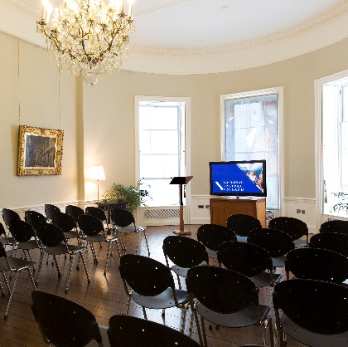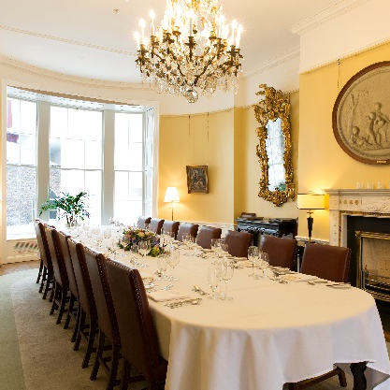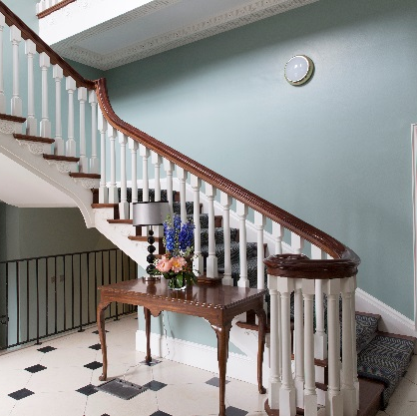

Our suite of elegant Georgian Rooms at No. 5 South Leinster Street offer a variety of options for your event. The recently refurbished rooms can accommodate meetings, dinners, workshops, and receptions, and we are certain your guests will enjoy being surrounded by works from the National Collection.
If you are interested in learning more about facilitating a private Tipple with Art event for parties or team building, contact us at events@ngi.ie.

This unique space has the luxury of its own private entrance. Your guests will be thrilled with the exciting experience of being in a part of the Gallery accessible only to Friends.

Deepen the connection to the Gallery by incorporating a tour into your evening or to break up the humdrum of an all-day meeting. We are happy to organise private tours of the collection.

Dimensions | Lavery Room: 9m x 5.9m  Clarke Room: 10.5m x 5.7m  Purser Room: 5.7m x 5.4m
Capacity | Dinner: 40 people  Reception: 50 people  Meetings: 22 people (Depending on required setup)  Lecture: 40 people
Rental Cost | Full Day: €1,500+VAT  Half Day: €1,200+VAT  Evening: €2,500+VAT  Weekend Evening: €3,500+VAT
Public Liability Insurance | Public Liability Insurance must be put in place for an event, and is the responsibility of those hiring the venue. Cover to the value of €6,500,000 is required.

Atrium
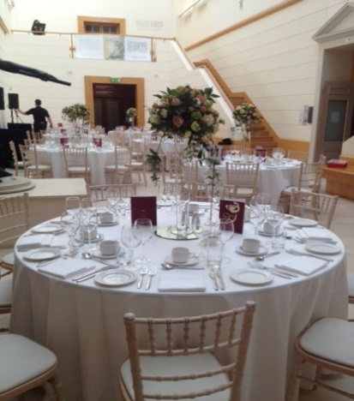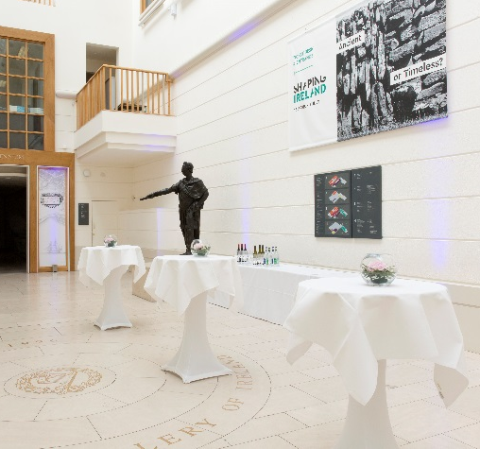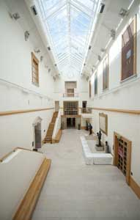

The Atrium is a spacious and light-filled venue with a double-height roof. This space can accommodate up to 70 for dinner and 100 for a reception.

Centrally located in the heart of the building’s Beit Wing, its close proximity to the galleries make it an ideal location for a drinks reception incorporating tours of the collection.

Dimensions | 20.35m x 6.36m
Capacity | Dinner: 70 people  Reception: 100 people  Lecture: 100 people
Rental Cost | Evening: €4,000+VAT  Weekends: €6,000+VAT
Public Liability Insurance | Public Liability Insurance must be put in place for an event, and is the responsibility of those hiring the venue. Cover to the value of €6,500,000 is required.

Wintergarden and Millennium Foyer
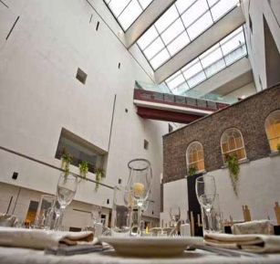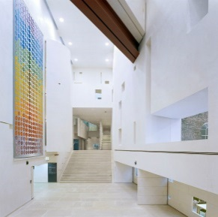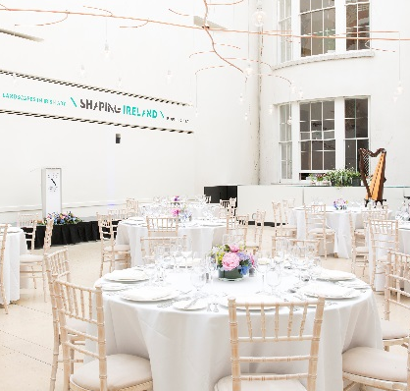

Originally the garden of the Georgian house overlooking it, the Wintergarden is a bright, double-height space located in our Millennium Wing.

Functioning as our café by day, this space becomes an elegant and exciting venue space by night and lends itself to a variety of events.

We are happy to organise private tours of the collection, in the adjoining galleries, as part of your event.

Dimensions | Wintergarden: 12.5m x 11.9m  MW Foyer: 23m x 6.6m
Capacity | Dinner: 160 people  Reception: 300 people  Lecture: 120 people
Rental Cost | Evening: €4,000+VAT  Weekends: €6,000+VAT
Public Liability Insurance | Public Liability Insurance must be put in place for an event, and is the responsibility of those hiring the venue. Cover to the value of €6,500,000 is required.

Lecture Theatre
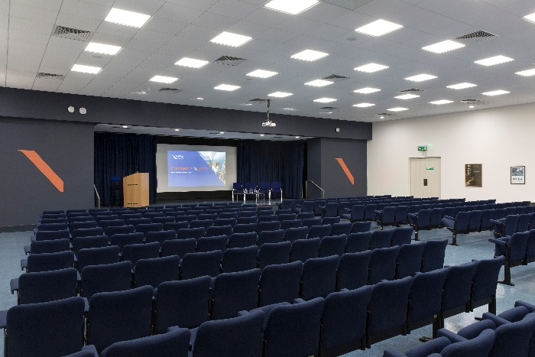

The Lecture Theatre at the National Gallery of Ireland is a comfortable and centrally located conference facility with a capacity of 260 seats in fixed theatre style. It is a fully equipped auditorium with an integrated projector, audio system and free Wi-Fi service. Host your conference, presentations, or panel discussion with the confidence that all of your needs will be attended to. Deepen the connection to the Gallery by incorporating a tour to break up an all-day meeting. We are happy to organise private tours of the collection.

Dimensions | 15.6m x 8.5m
Capacity | Lecture: 260 people
Rental Cost | Half Day: €1,200+VAT  Full Day: €2,000+VAT  Evening: €4,000+VAT  Weekend Evening: €6,000+VAT
Equipment Available | Projector – Screen – Lectern – Lectern Mic – 2 Roving Mics – 2 Lapel Mics – 3 Table Mics  We support VGA. Apple Thunderbolt to VGA adapter provided on request.  For users with only HDMI output, a HDMI to VGA adapter can be provided on request.
Public Liability Insurance | Public Liability Insurance must be put in place for an event, and is the responsibility of those hiring the venue. Cover to the value of €6,500,000 is required.

Courtyard
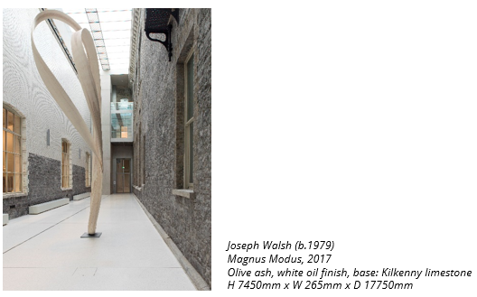

The Courtyard was created by architects Heneghan Peng as part of the refurbishment project of the historic wings. Situated between the 1864 Dargan wing and the 1903 Milltown wing on Merrion Square, the Courtyard is the perfect light-filled venue for a reception or networking event.

This space is exclusive to Corporate Partners, and is not available for individual private hire. Please contact the Events Team at events@ngi.ie for more information about Corporate Partnerships.

Dimensions | 45.28m x 6m
Capacity | Reception: 220 people
Rental Cost | Exclusive to Corporate Partners. Please contact the Events Team at events@ngi.ie for more information.
Public Liability Insurance | Public Liability Insurance must be put in place for an event, and is the responsibility of those hiring the venue. Cover to the value of €6,500,000 is required.

Shaw Room
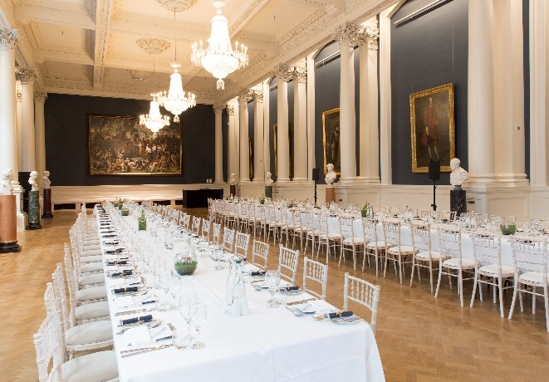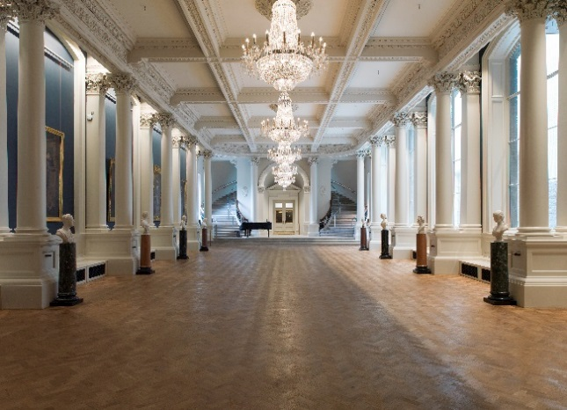

One of the most stunning spaces in the Gallery is the Shaw Room, named after George Bernard Shaw. Shaw bequeathed one third of his royalties to the National Gallery of Ireland, which he documented as being of significant influence throughout his childhood. The Shaw Room was part of the refurbishment project of the historic wings, and is home to Daniel Maclise’s The Marriage of Aoife and Strongbow (1854). The Shaw Room is a gorgeous venue for gala dinners or receptions.

This space is exclusive to Corporate Partners, and is not available for individual private hire. Please contact the Events Team at events@ngi.ie for more information about Corporate Partnerships.

Dimensions | 26.9m x 10.75m
Capacity | Dinner on Long Tables: 252 people  Dinner on Round Tables: 170  Reception: 300 people  Lecture: 200 people
Rental Cost | Exclusive to Corporate Partners. Please contact the Events Team at events@ngi.ie for more information.
Public Liability Insurance | Public Liability Insurance must be put in place for an event, and is the responsibility of those hiring the venue. Cover to the value of €6,500,000 is required.

